PLMUN GO
Project title: PLMUN GO: An Offline Campus Map and Building Directory Application
Acronym: PLMUN GO “Your journey starts here”
Institution: Pamantasan ng Lungsod ng Muntinlupa (PLMUN)
Project type: Android mobile application
Proposed interface: Dark and light mode
Project scope: Offline campus map, building directory, building information, and floor plans. Turn-by-turn navigation and walking routes are excluded.
1. Project overview
PLMUN GO is an Android application designed to help students and campus visitors explore and locate buildings within the PLMUN campus. The application provides an offline campus map, a searchable directory of buildings, building information, and floor plans that can be viewed without an internet connection.
The application will have one shared login page, followed by separate experiences for students and administrators.
Students can browse campus information, while authorized administrators can manage building names, information, and floor plans.
The user interface will follow a modern, simple, and accessible design using a dark background with blue and gold accents inspired by the group's existing logo.
2. Project objectives
General objective
To design and develop an offline Android campus map and building directory application that allows students and campus visitors to easily access campus information through a simple and user-friendly interface.
Specific objectives
- To provide an offline campus map showing the locations and names of campus buildings.
- To develop a searchable campus building directory.
- To display building descriptions, facilities, and floor plans.
- To provide Student and Admin account functionality.
- To allow authorized administrators to edit building information and floor plans.
- To implement dark and light mode options.
- To evaluate the usability and effectiveness of the proposed application through user testing.

3. UI/UX information architecture
PLMUN GO application structure
Screen 01
Welcome / Login Screen
Screen 01
Logo · PLMUN GO · Log in · Sign up

Screen 02
Home / Campus Map
Search · Building markers · Campus exploration

Screen 03
Building Details
Name · Description · Facilities · Floor plans

Screen 04
Floor Plan Viewer
Floor selection · Rooms · Building layout

Screen 05
Admin Account
Dashboard · Building edit · Add new Building

Screen 06
Settings / Profile
Theme · Account · About · Log out

4. Detailed UI screen documentation

Screen 01 - Welcome and Login
The combined splash and login screen introduces the application and allows registered users to access their accounts.

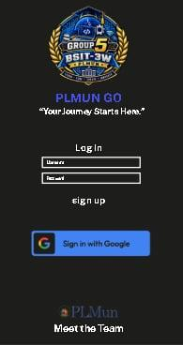

UI elements
- Group 5 BSIT PLMUN logo.
- App name: PLMUN GO.
- Tagline: “Your Journey Starts Here.”
- Username and password input fields.
- Log In button.
- Sign up link.
- Sign in with Google button.
- Meet the Team link.
Function: Existing users log in; new users proceed to account registration. The Meet the Team page is an optional supporting page for the project.

Screen 02 — CAMPUS MAP
Home / Campus Map
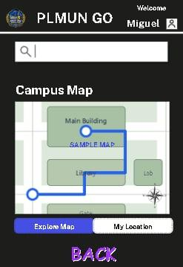

UI elements
- Search bar.
- Offline map display.
- Building markers.
- Campus building labels.
- My Location button.
- Profile and settings access.
Function: Students can explore the campus map, tap a building marker, or search for a building to open its information page. The map is designed to work without internet access once its offline data is available.

Screen 03 — Building Information
Building Name:
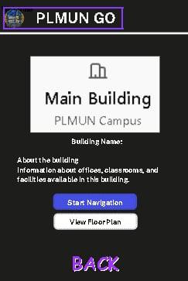

UI elements: Building name, building description, facilities list, image or map preview, View Floor Plan button.
Function: Displays information about a selected campus building and allows users to access its floor plan. The previous Start Navigation button is removed.
Screen 04 — Floor Plan Viewer
Building Name: — Floor Plan:
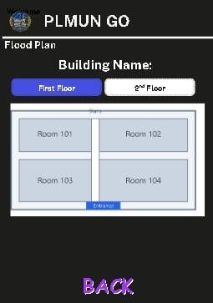

Sample floor plan. Actual PLMUN building layouts will be used in the final prototype.
UI elements: Floor selector, room labels, building entrances, stairs, and back button.
Function: Users can view the floor layout of a building and identify rooms or facilities. The floor plan is for information and reference, not for calculating an indoor route. Also includes emergency exit route.
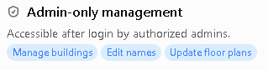
Screen 05 — Admin Dashboard
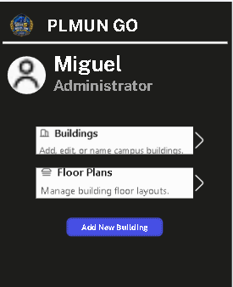

Screen 06 — Settings / Profile

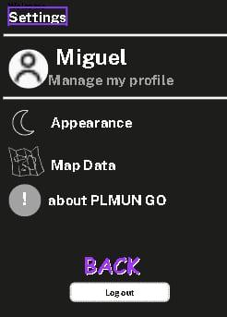

Function: Allows users to manage their profile, switch between dark and light mode, check offline map availability, and view application information.

Design system and color palette
The design will use a consistent color system across all screens, with a dark theme as the main visual identity and a light theme as an alternative.
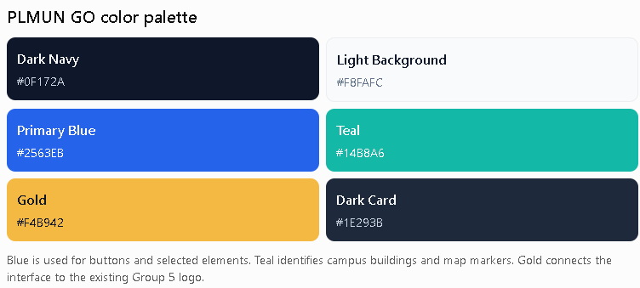

Functional requirements
The application should be able to:
- Display an offline campus map.
- Search campus buildings.
- Show building information.
- Display floor plans.
- Support student and admin accounts.
- Allow authorized admins to edit building details.
- Provide dark and light themes.
- Display an offline availability status.
Non-functional requirements
- Usability: The interface should be easy for first-time users to understand.
- Performance: The campus map and building directory should load without requiring an internet connection.
- Accessibility: Text and buttons should have adequate contrast and readable sizes.
- Security: Admin-only management features should require proper authorization.
- Maintainability: Building data and floor plans should be organized so they can be updated without redesigning every screen.

Scope and limitations
Included in the proposed system
- Offline campus map and building directory.
- Searchable campus buildings.
- Building descriptions and facilities.
- Floor plan viewing.
- Student and Admin accounts.
- Admin building management.
- Dark and light mode.
- Offline map availability information.
Excluded from the proposed system
- Turn-by-turn walking directions.
- Route calculation.
- Online map navigation.
- Real-time traffic and road conditions.
- General city-wide navigation.
- Live GPS route guidance.
- Limited detail on building due to data privacy and other consensual issues.

MEET THE TEAM
Meet the Team Page
The Meet the Team page introduces the members responsible for the development of PLMUN GO. Each team member is represented through a profile card containing their photo, name, role, and a button that provides additional information about their responsibilities and contributions to the project.
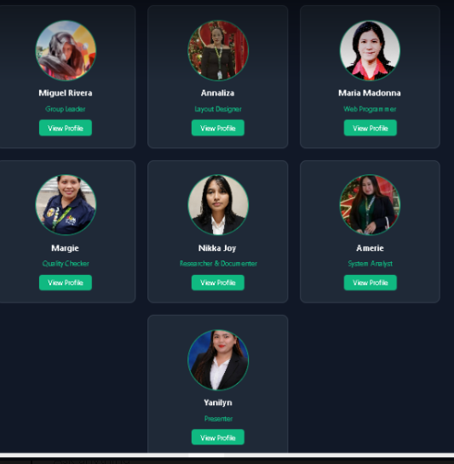

Meet the Team page
- Miguel Rivera — Group Leader
- Annaliza — Layout Designer
- Maria Madonna — Web Programmer
- Margie — Quality Checker/Tester
- Nikka Joy — Researcher & Documenter
- Amerie — System Analyst
- Yanilyn — Presenter
- Dexter Imeperial – Backend/Researcher, Data Gathering

Each card has:
Profile picture → Name → Role → View Profile
When View Profile is selected, it can open a separate profile page containing:
- Larger profile picture
- Full name
- Position/role
- Short biography
- Skills
- Contribution to PLMUN GO
- Add new member
- Back button

Comment and Suggestion Page
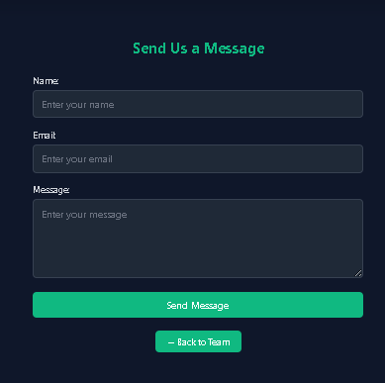

The Comment & Suggestion feature allows students to provide feedback regarding the usability, campus information, map content, building information, and overall functionality of PLMUN GO. This provides a mechanism for collecting user feedback that can be used to improve the application.

